**Heading:** Sprint 3 plan, MemLoc, Remind by Location, sprint completion date: 02.22, rev 1, 02/09/2022

Goal: Connecting the front end aspects to the backend aspects of the code, so that we can create a functional mvp.

**Task listing**

User story 1 : As a user, I want to be able to add a location for my tasks and for the app to know where my current location is. (7 points)

1. Add a location field to items (3 hours)
2. Set up a hook or some other system to run every so often and pull the current location from the backend API (3 hours)

User story 2: As a user, I want to be able to prioritize my todo list items based on my current location. (5 points)

1. Compare current location to the locations listed in todo list. (2 hours)
2. If current location is same as one on todo list send todo make popup (will send this to phone next sprint) ( 2 hours)

User story 3: As a user, I want to be able to tag a todo list item with a timestamp, and prioritize it based on the current time. (9 points

1. Get current time/date and compare it to date listed (6 hours)
2. Tag todo list item with timestamp (4 hours)
3. Trigger based on current time (3 hours)
4. Prioritize list (3 hours)

**Team roles:**

Alexandra: Frontend

Mythili: Frontend

Abirami: Scrum Master, Frontend

Surya Rani: Backend

Case Delst: Product Owner, Backend, Frontend

Initial task assignment: A listing of each team member, with their first user story and task

assignment. This should look like:

Alexandra: user story 1, task 1

Mythili: user story 2, task 2

Abirami: user story 3, task 1, user story 3 task 3

Surya Rani: User story 2, Task 1

Case Delst: (3) Misc backend cleanup and testing, user story 3, task 2

Initial burnup chart: A graph giving the initial burnup chart for this sprint and is labeled as such

with sprint number and project name and is located in the lab.

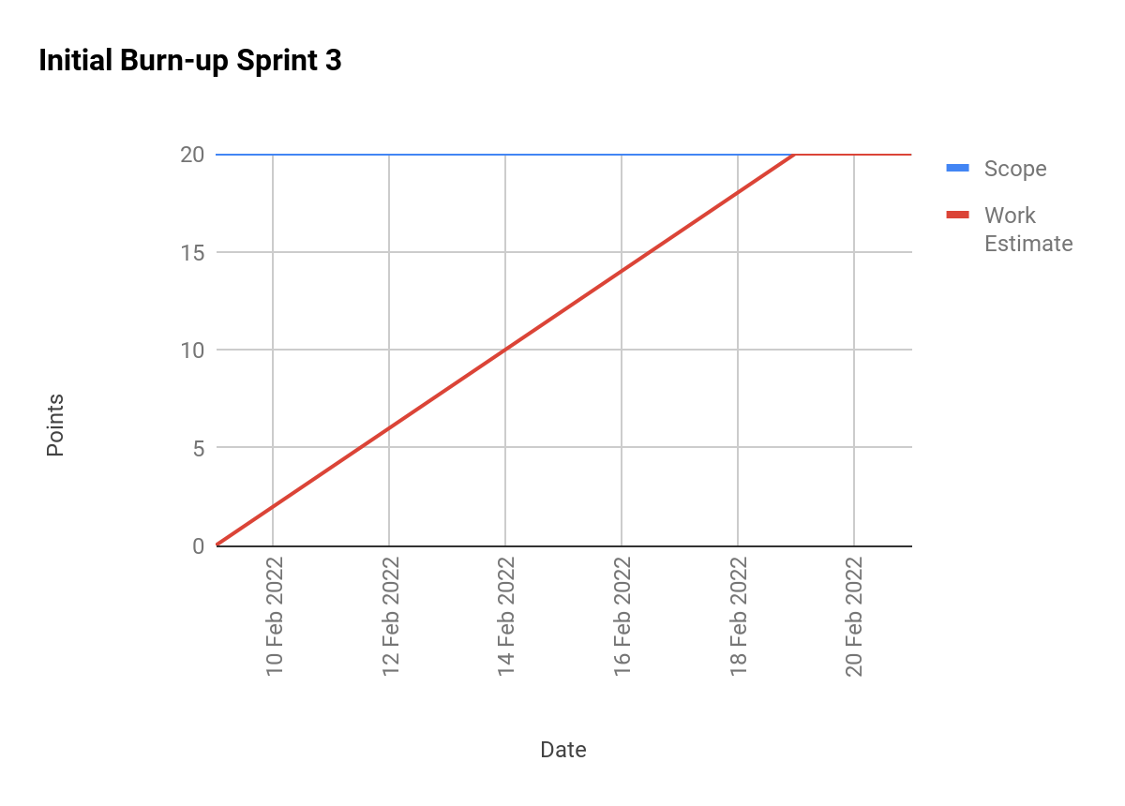

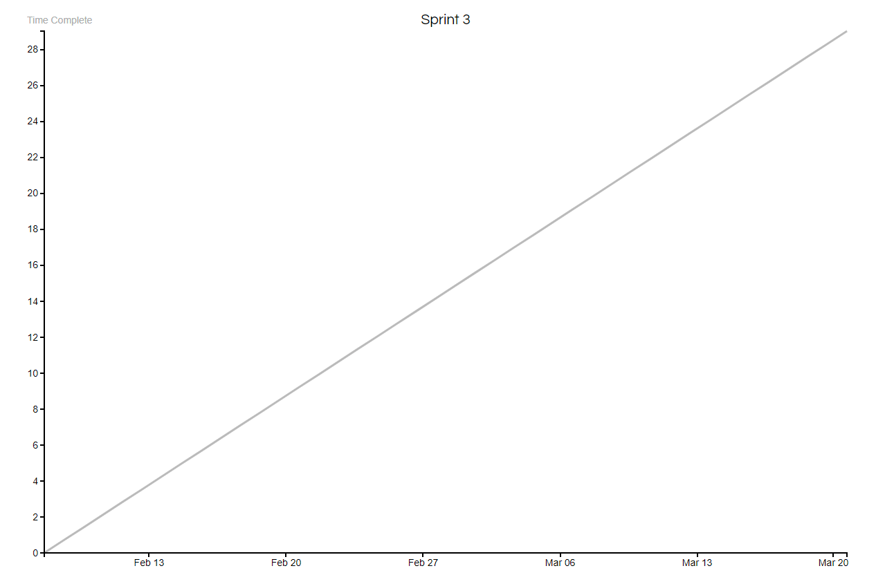

scrum board:

<https://trello.com/b/6cgzDjp5/memloc-s3>

Scrum times:

Monday/Wednesday/Friday @ 3pm

Meeting with TA Tuesday @ 3 pm